BOOK ONLINE AT WW.BTKD.CO.UK  
OR CALL 01844 281 888  
  
PATTERNS ~ SPARRING ~   
TAG-TEAM SPARRING ~ BREAKING

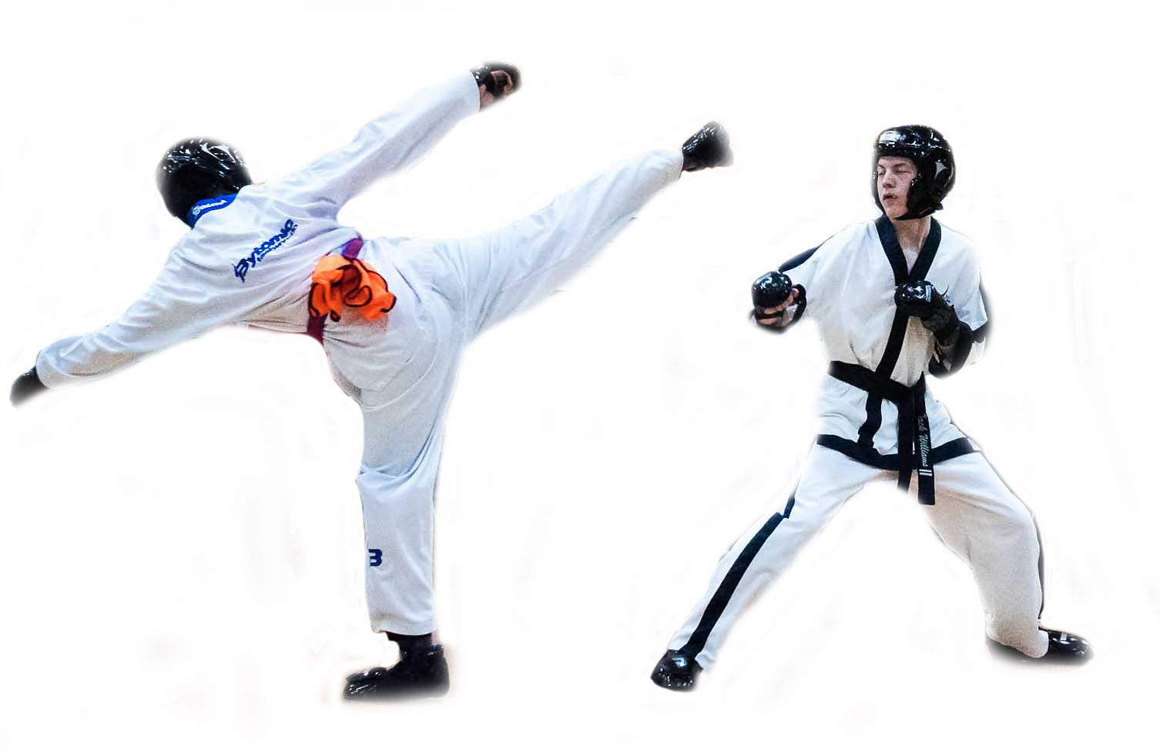

SUNDAY 24TH SEPTEMBER  
WINDSOR LEISURE CENTRE  
SL4 5JB  
  
OPEN TO ALL   
GRADES AND AGES  
  
£10 for one event  
£25 for two or all events  
£5 spectators  
  
ONE FREE SPECTATOR AND  
 FREE PARKING WITH EVERY ENTRY   
(COLLECT TICKET WHEN YOU SIGN IN)

NEXT BTKD TOURNAMENT